Angelo Vita 4/19/23

In programming, a stack is a data structure that follows the "last-in, first-out". This is also referred to as the LIFO principle. It's similar to a stack of books or plates, where the most recently added item is placed at the top and the oldest item is placed at the bottom. There are two main operations for a stack. The first one is to push. Pushing is when an item is added to the top of the stack. The second operation is pop. Popping is when an item is removed from the top of the stack.

In programming, a delimiter is a special character or sequence of characters that is used to mark the beginning or end of specific sections of code or data. Delimiters are used to define the boundaries between different elements in a program. The brackets used in this assignment are rounded, square, and curly parentheses. Some programming languages also allow the use of custom delimiters, which can be defined by the programmer. These delimiters can be used to mark the beginning or end of specific sections of code, such as function or class definitions. In addition to marking the boundaries between different elements, delimiters can also be used to help parse or interpret code or data.

In this assignment, I was tasked with creating a program that checks the delimiters in a line of text typed by the user. Each opening or left delimiter should be matched by a closing or right delimiter; that is, every { should be followed by a matching } and so on. Also, opening delimiters that occur later in the string should be closed before those occurring earlier. The way I did this was by using a stack. The program starts by using a scanner to ask the user to enter the delimiters.

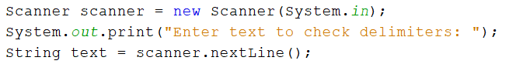

Then the code uses a stack to keep track of opening delimiters encountered in the string. For each delimiter in the input string, the code checks if it is an opening delimiter or a closing delimiter. If it is an opening delimiter, the code pushes it onto the stack. If it is a closing delimiter, the code checks if it matches the most recently opened delimiter. If it does not match or the stack is empty, the code returns false. After processing the entire input string, the code checks if the stack is empty. If it is empty, it means all opening delimiters have a matching closing delimiter, and the code returns true. Otherwise, the code returns false. 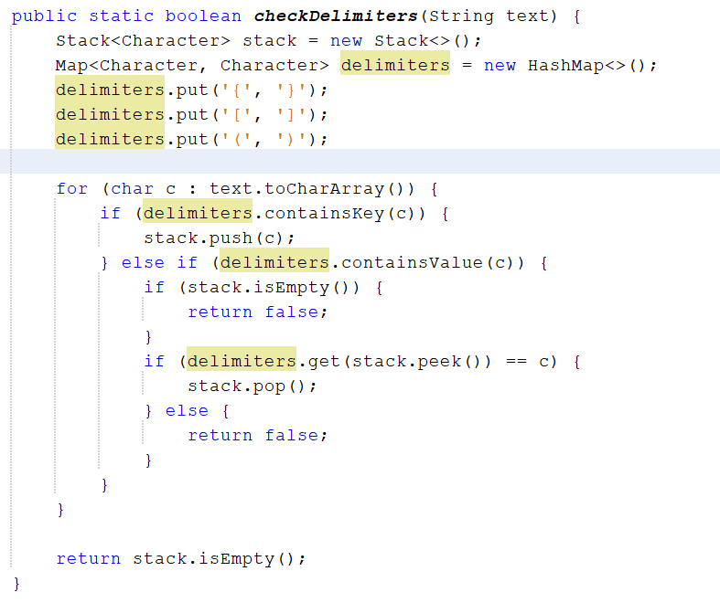

The program will then output a message, telling the user whether the delimiters were matched correctly or not.

